A Project Report
On
ARTIFICIAL INTELLIGENCE
Submitted in partial fulfilment of the for the award of degree of requirement
BACHELOR OF TECHNOLOGY
IN
COMPUTER SCIENCE AND ENGINEERING
Submitted By
A. DILEEP KUMAR (21HQ1A4203)
B. PRADEEP KUMAR (21HQ1A4205)
D.SHIVASURYAVARAPRASAD (21HQ1A4209)
D.SRIVARSHINI (21HQ1A4211)
G. MIDHIN KUMAR (21HQ1A4213)
P. VASANTHA (21HQ1A4241)


Under the Guidance of
MR.H.DEVARAJ
Assistant Professor
Department of CSE

AVANTHI’S RESEARCH & TECHNOLOGICAL ACADEMY
(AFFILIATED TO JAWAHARLAL NEHRU TECHNOLOGICAL UNIVERSITY GURAJADA VIZIAGARAM, A.P) BASAVAPALEM(V), BHOGAPURAM(M), VIZIANAGARAM (D)

AVANTHI’S RESEARCH & TECHNOLOGICAL ACADEMY
(AFFILIATED TO JAWAHARLAL NEHRU TECHNOLOGICAL UNIVERSITY GURAJADA VIZIAGARAM, A.P) BASAVAPALEM(V), BHOGAPURAM(M), VIZIANAGARAM (D)


BONAFIDE CERTIFICATE

This is to Certify that this project report “Artificial intelligence “is the bonified work “A. DILEEP KUMAR (21HQ1A4203) B. PRADEEP KUMAR (21HQ1A4205), D. SHIVA SURYA VARA PRASAD (21HQ1A4209), D. SRIVARSHINI (21HQ1A4211), G. MIDHIN KUMAR (21HQ1A4213), P. VASANTHA (21HQ1A4241)” who carried out Project work under our supervision. The results embodied in this project have been verified and found Satisfactory.

INTERNAL GUIDE | HEAD OF THE DEPARTMENT
Mr.H. Devaraj | Mrs. B. SAILAJA
Asst. Professor | HOD
Department of CSE | Department of CSE

ACKNOWLEDGEMENT

We would like to extend our sincere gratitude to all those who help us in our project.
We express our sincere thanks to our guide MR.H.DEVARAJ who has been source of inspiration for us throughput our project for her/his valuable advices in making our project success.
We owe our gratitude to our beloved, Mrs. B. SAILAJA, HOD for assisting us to complete our project work.
We are also thankful to our honorable principal sir DR. P. GOVINDA RAO principal of “AVANTHI’S RESEARCH AND TECHNOLOGICAL ACAMEDY, BHOGAPURAM” who has shown keen interest in us & encourage us by providing all the facilities to complete our project successfully.
We also thankful to our institution and our family members, without them this project would have been a distant reality.
Thanks, and appreciation for those who helped us and supported us to make our project successful.

PROJECT ASSOCIATES

A. DILEEP KUMAR (21HQ1A4203)
B. PRADEEP KUMAR (21HQ1A4205)
D.SHIVASURYAVARAPRASAD (21HQ1A4209)
D.SRIVARSHINI (21HQ1A4211)
G. MIDHIN KUMAR (21HQ1A4213)
P. VASANTHA (21HQ1A4241)

DECLARATION

We “A. DILEEP KUMAR (21HQ1A4203) B. PRADEEP KUMAR (21HQ1A4205), D. SHIVA SURYA VARA PRASAD (21HQ1A4209), D. SRIVARSHINI (21HQ1A4211), G. MIDHIN KUMAR (21HQ1A4213), P. VASANTHA (21HQ1A4241)” here by declare that the
project report entitled “Artificial intelligence” is an original and authentic work done
in the Department of COMPUTER SCIENCE AND ENGINEERING submitted in partial fulfilment of the requirements for the award of the degree of Bachelor of Technology The matter embodied in this project work has not been submitted earlier forward of any degree or diploma to the best of my knowledge.

PROJECT ASSOCIATES

A. DILEEP KUMAR (21HQ1A4203)
B. PRADEEP KUMAR (21HQ1A4205)
D.SHIVASURYAVARAPRASAD (21HQ1A4209)
D.SRIVARSHINI (21HQ1A4211)
G. MIDHIN KUMAR (21HQ1A4213)
P. VASANTHA (21HQ1A4241)

Table of Contents
S. No. TITLE PAGE NO.

- Artificial intelligence

- Introduction……………………………………………….
- Over view of AI……………………………………………
- The history of artificial intelligence……………………….
- Types of Artificial Intelligence………………………………
- Future of AI………………………………………………….
- Applications of AI……………………………………………
- The Need for AI……………………………………………...
- Challenges of AI ……………………………………………....
- Conclusion……………………………………………………

CHAPTER:1

Artificial intelligence

Introduction

(AI) refers to the simulation of human intelligence in machines that are programmed to think and act like humans. It involves the development of algorithms and computer programs that can perform tasks that typically require human intelligence such as visual perception, speech recognition, decision-making, and language translation. AI has the potential to revolutionize many industries and has a wide range of applications, from virtual personal assistants to self-driving cars.
A system is rational if it does the “right thing,” given what it knows. Historically, all four approaches to AI have been followed, each by different people with different methods. A human-centered approach must be in part an empirical science, in the problem and at the same time opportunity with AI is that it’s not very well defined.
If we would show the navigation system of our car to someone living in 1980, he or she would probably consider it as a form of Artificial Intelligence, whereas we nowadays would probably not. We are seeing the same with speech and image recognition, natural language recognition, game engines and other technologies that are becoming more and more common and embedded in every-day technology.
On the other hand, various technology solution providers are taking the opportunity to rebrand their existing solutions to AI, to take advantage of the huge hype and that the market is experiencing and the resulting press coverage.
If we have a built a machine learning model that predicts customer demand, a solution that has been existing for years, we would have called it “data mining” in the past and we now see it rebranded as “artificial intelligence”. This is adding to the confusion and may very well lead to inflated expectations Nevertheless, recent developments in AI are impressive and exciting. But also overestimated and misunderstood.
In order to split hype from reality and help forming a view on this market, we will publish a series of articles explaining the world of AI, zooming in to the techniques that are associated with AI, the most appealing business applications and potential issues we can expect.
In this first article we will start with the beginning, by explaining AI and associated terms in five definitions. What is AI? What is Machine Learning? What is Cognitive Analytics? How do these terms relate, or differ, from one another?

Overview of AI

Artificial Intelligence

Artificial Intelligence (AI) has been an integral part of our lives whether we have realized it or not. When we book a ticket online, scroll through our newsfeed on our social networking account, or read the recommendations from an ecommerce site, we are engaging with an AI component in the background (Medium, 2019). Even the simple chat assistant that we sometimes encounter whilst shopping online or ordering food is driven by AI.

A way of making a computer, robot or software think and act like human.
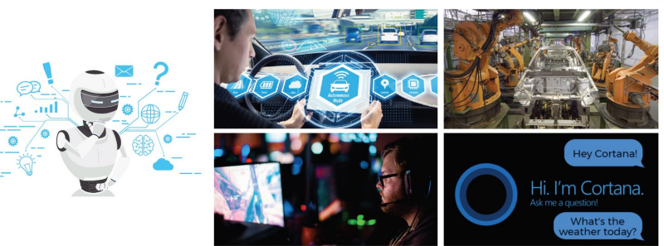
Fig 1.1: Applications of Artificial Intelligence
Artificial Intelligence is an attempt to make a computer, a robot, or other piece of technology ‘think’ and process data in the same way as we humans do. AI therefore has to study how the human brain ‘thinks’, learns, and makes decisions when it tries to solve problems or execute a task. The aim of AI is to improve technology by adding functionality related to the human acts of reasoning, learning, and problem-solving. Here are a few practical examples to demonstrate how AI has penetrated our everyday lives to provide services that we can use extensively to make our lives easier

THE HISTORY OF ARTIFICIAL INTELLIGENCE

The gestation of artificial intelligence (1943–1955)

The first work that is now generally recognized as AI was done by Warren McCulloch and Walter Pitts (1943). They drew on three sources: knowledge of the basic physiology and function of neurons in the brain; a formal analysis of propositional logic due to Russell and Whitehead; and Turing’s theory of computation. They proposed a model of artificial neurons in which each neuron is characterized as being “on” or “off,” with a switch to “on” occurring in response to stimulation by a sufficient number of neighboring neurons. The state of a neuron was conceived of as “factually equivalent to a proposition which proposed its adequate stimulus.” They showed, for example, that any computable function could be computed by some network of connected neurons, and that all the logical connectives (and, or, not, etc.) could be implemented by simple net structures. McCulloch and Pitts also suggested that suitably defined networks could learn. Donald Hebb (1949) demonstrated a simple updating rule for modifying the connection strengths between neurons. His rule, now called Hebbian learning, remains an influential model to this day
Two undergraduate students at Harvard, Marvin Minsky and Dean Edmonds, built the first neural network computer in 1950. The SNARC, as it was called, used 3000 vacuum tubes and a surplus automatic pilot mechanism from a B-24 bomber to simulate a network of 40 neurons. Later, at Princeton, Minsky studied universal computation in neural networks. His Ph.D. committee was skeptical about whether this kind of work should be considered mathematics, but von Neumann reportedly said, “If it isn’t now, it will be someday.” Minsky was later to prove influential theorems showing the limitations of neural network research.

The birth of artificial intelligence (1956)

Princeton was home to another influential figure in AI, John McCarthy. After receiving his PhD there in 1951 and working for two years as an instructor, McCarthy moved to Stanford and then to Dartmouth College, which was to become the official birthplace of the field. McCarthy convinced Minsky, Claude Shannon, and Nathaniel Rochester to help him bring together U.S. researchers interested in automata theory, neural nets, and the study of intelligence. They organized a two-month workshop at Dartmouth in the summer of 1956. The proposal states:10 We propose that a 2-month, 10-man study of artificial intelligence be carried out during the summer of 1956 at Dartmouth College in Hanover, New Hampshire. The study is to proceed on the basis of the conjecture that every aspect of learning or any other feature of intelligence can in principle be so precisely described that a machine can be made to simulate it. An attempt will be made to find how to make machines use language, form abstractions and concepts, solve kinds of problems now reserved for humans, and improve themselves. We think that a significant advance can be made in one or more of these problems if a carefully selected group of scientists work on it together for a summer. There were 10 attendees in all, including Trenchard More from Princeton, Arthur Samuel from IBM, and Ray Solomon off and Oliver Selfridge from MIT. Two researchers from Carnegie Tech,11 Allen Newell and Herbert Simon, rather stole the show. Although the others had ideas and in some cases programs for particular applications such as checkers, Newell and Simon already had a reasoning program, the Logic Theorist (LT), about which Simon claimed, “We have invented a computer program capable of thinking non-numerically, and thereby solved the venerable mind–body problem.

Early enthusiasm, great expectations (1952–1969)

The program was demonstrated on television in February 1956, creating a strong impression. Like Turing, Samuel had trouble finding computer time. Working at night, he used machines that were still on the testing floor at IBM’s manufacturing plant. Chapter 5 covers game playing, and Chapter 21 explains the learning techniques used by Samuel. John McCarthy moved from Dartmouth to MIT and there made three crucial contributions in one historic year: 1958. In MIT AI Lab Memo No. 1, McCarthy defined the high-level LISP language Lisp, which was to become the dominant AI programming language for the next 30 years. With Lisp, McCarthy had the tool he needed, but access to scarce and expensive computing resources was also a serious problem. In response, he and others at MIT invented time sharing. Also in 1958, McCarthy published a paper entitled Programs with Common Sense, in which he described the Advice Taker, a hypothetical program that can be seen as the first complete AI system. Like the Logic Theorist and Geometry Theorem Prover, McCarthy’s program was designed to use knowledge to search for solutions to problems. But unlike the others, it was to embody general knowledge of the world. For example, he showed how some simple axioms would enable the program to generate a plan to drive to the airport. The program was also designed to accept new axioms in the normal course of operation, thereby allowing it to achieve competence in new areas without being reprogrammed. The Advice Taker thus embodied the central principles of knowledge representation and reasoning: that it is useful to have a formal, explicit representation of the world and its workings and to be able to manipulate that representation with deductive processes. It is remarkable how much of the 1958 paper remains relevant today. Work at Stanford emphasized general-purpose methods for logical reasoning. Applications of logic included Cordell Green’s question-answering and planning systems (Green, 1969b) and the Shakey robotics project at the Stanford Research Institute (SRI). The latter project, discussed further in Chapter 25, was the first to demonstrate the complete integration of logical reasoning and physical activity.
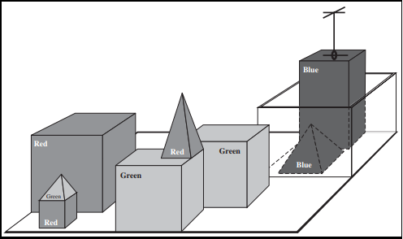

Figure: A scene from the block’s world. SHRDLU (Winograd, 1972) has just completed the command “Find a block which is taller than the one you are holding and put it in the box.”

The blocks world was home to the vision project of David Huffman (1971), the vision and constraint-propagation work of David Waltz (1975), the learning theory of Patrick Winston (1970), the natural-language-understanding program of Terry Winograd (1972), and the planner of Scott Fahlman (1974)

Knowledge-based systems: The key to power? (1969–1979)

The picture of problem solving that had arisen during the first decade of AI research was of a general-purpose search mechanism trying to string together elementary reasoning steps to WEAK METHOD find complete solutions. Such approaches have been called weak methods because, although general, they do not scale up to large or difficult problem instances. The alternative to weak methods is to use more powerful, domain-specific knowledge that allows larger reasoning steps and can more easily handle typically occurring cases in narrow areas of expertise. One might say that to solve a hard problem, you have to almost know the answer already.
The DENDRAL program (Buchanan et al., 1969) was an early example of this approach. It was developed at Stanford, where Ed Feigenbaum (a former student of Herbert Simon), Bruce Buchanan (a philosopher turned computer scientist), and Joshua Lederberg (a Nobel laureate geneticist) teamed up to solve the problem of inferring molecular structure from the information provided by a mass spectrometer. The input to the program consists of the elementary formula of the molecule (e.g., C6H13NO2) and the mass spectrum giving the masses of the various fragments of the molecule generated when it is bombarded by an electron beam. For example, the mass spectrum might contain a peak at m = 15, corresponding to the mass of a methyl (CH3) fragment.
The widespread growth of applications to real-world problems caused a concurrent increase in the demands for workable knowledge representation schemes. A large number of different representation and reasoning languages were developed. Some were based on logic—for example, the Prolog language became popular in Europe, and the PLANNER family in the United States. Others, following Minsky’s idea of frames (1975), adopted a more structured approach, assembling facts about particular object and event types and arranging the types into a large taxonomic hierarchy analogous to a biological taxonomy.

AI becomes an industry (1980–present)

The first successful commercial expert system, R1, began operation at the Digital Equipment Corporation (McDermott, 1982). The program helped configure orders for new computer systems; by 1986, it was saving the company an estimated $40 million a year. By 1988, DEC’s AI group had 40 expert systems deployed, with more on the way. DuPont had 100 in use and 500 in development, saving an estimated $10 million a year. Nearly every major U.S. corporation had its own AI group and was either using or investigating expert systems.
In 1981, the Japanese announced the “Fifth Generation” project, a 10-year plan to build intelligent computers running Prolog. In response, the United States formed the Microelectronics and Computer Technology Corporation (MCC) as a research consortium designed to assure national competitiveness. In both cases, AI was part of a broad effort, including chip design and human-interface research. In Britain, the Alvey report reinstated the funding that was cut by the Lighthill report.13 In all three countries, however, the projects never met their ambitious goals.
Overall, the AI industry boomed from a few million dollars in 1980 to billions of dollars in 1988, including hundreds of companies building expert systems, vision systems, robots, and software and hardware specialized for these purposes. Soon after that came a period called the “AI Winter,” in which many companies fell by the wayside as they failed to deliver on extravagant promises.

The return of neural networks (1986–present)

In the mid-1980s at least four different groups reinvented the back-propagation learning algorithm first found in 1969 by Bryson and Ho. The algorithm was applied to many learning problems in computer science and psychology, and the widespread dissemination of the results in the collection Parallel Distributed Processing (Rumelhart and McClelland, 1986) caused great excitement.
These so-called connectionist models of intelligent systems were seen by some as direct competitors both to the symbolic models promoted by Newell and Simon and to the logicist approach of McCarthy and others (Smolensky, 1988). It might seem obvious that at some level humans manipulate symbols—in fact, Terrence Deacon’s book The Symbolic Species (1997) suggests that this is the defining characteristic of humans—but the most ardent connectionists questioned whether symbol manipulation had any real explanatory role in detailed models of cognition.
This question remains unanswered, but the current view is that connectionist and symbolic approaches are complementary, not competing. As occurred with the separation of AI and cognitive science, modern neural network research has bifurcated into two fields, one concerned with creating effective network architectures and algorithms and understanding their mathematical properties, the other concerned with careful modeling of the empirical properties of actual neurons and ensembles of neurons

The emergence of intelligent agents (1995–present)

Perhaps encouraged by the progress in solving the subproblems of AI, researchers have also started to look at the “whole agent” problem again. The work of Allen Newell, John Laird, and Paul Rosenbloom on SOAR (Newell, 1990; Laird et al., 1987) is the best-known example of a complete agent architecture. One of the most important environments for intelligent agents is the Internet. AI systems have become so common in Web-based applications that the “-bot” suffix has entered everyday language. Moreover, AI technologies underlie many Internet tools, such as search engines, recommender systems, and Web site aggregators.
Despite these successes, some influential founders of AI, including John McCarthy (2007), Marvin Minsky (2007), Nils Nilsson (1995, 2005) and Patrick Winston (Beal and Winston, 2009), have expressed discontent with the progress of AI.
They think that AI should put less emphasis on creating ever-improved versions of applications that are good at a specific task, such as driving a car, playing chess, or recognizing speech. Instead, they believe AI should return to its roots of striving for, in Simon’s words, “machines that think, that learn and that create.”
They call the effort human-level AI or HLAI; their first symposium was in 2004 (Minsky et al., 2004). The effort will require very large knowledge bases; Hendler et al. (1995) discuss where these knowledge bases might come from.
A related idea is the subfield of Artificial General Intelligence or AGI (Goertzel and ARTIFICIAL GENERAL INTELLIGENCE Pennachin, 2007), which held its first conference and organized the Journal of Artificial General Intelligence in 2008.
AGI looks for a universal algorithm for learning and acting in any environment, and has its roots in the work of Ray Solomon off (1964), one of the attendees of the original 1956 Dartmouth conference. Guaranteeing that what we create is really Friendly AI is also a concern (Yudkowsky, 2008; Omohundro, 2008), one we will return to in Chapter 26.

The availability of very large data sets (2001–present)

Throughout the 60-year history of computer science, the emphasis has been on the algorithm as the main subject of study. But some recent work in AI suggests that for many problems, it makes more sense to worry about the data and be less picky about what algorithm to apply.
This is true because of the increasing availability of very large data sources: for example, trillions of words of English and billions of images from the Web (Kilgarriff and Grefenstette, 2006); or billions of base pairs of genomic sequences (Collins et al., 2003).
One influential paper in this line was Yarowsky’s (1995) work on word-sense disambiguation: given the use of the word “plant” in a sentence, does that refer to flora or factory? Previous approaches to the problem had relied on human-labeled examples combined with machine learning algorithms. Yarowsky showed that the task can be done, with accuracy above 96%, with no labeled examples at all.
Instead, given a very large corpus of unannotated text and just the dictionary definitions of the two senses “works, industrial plant” and “flora, plant life”one can label examples in the corpus, and from there bootstrap to learn new patterns that help label new examples.
Banko and Brill (2001) show that techniques like this perform even better as the amount of available text goes from a million words to a billion and that the increase in performance from using more data exceeds any difference in algorithm choice; a mediocre algorithm with 100 million words of unlabelled training data outperforms the best-known algorithm with 1 million words.
As another example, Hays and Efros (2007) discuss the problem of filling in holes in a photograph. Suppose you use Photoshop to mask out an ex-friend from a group photo, but now you need to fill in the masked area with something that matches the background. Hays and Efros defined an algorithm that searches through a collection of photos to find something that will match.
They found the performance of their algorithm was poor when they used a collection of only ten thousand photos, but crossed a threshold into excellent performance when they grew the collection to two million photos.
Work like this suggests that the “knowledge bottleneck” in AI—the problem of how to express all the knowledge that a system needs—may be solved in many applications by learning methods rather than hand-coded knowledge engineering, provided the learning algorithms have enough data to go on (Halevy et al., 2009).
Reporters have noticed the surge of new applications and have written that “AI Winter” may be yielding to a new Spring (Havenstein, 2005). As Kurzweil (2005) writes, “today, many thousands of AI applications are deeply embedded in the infrastructure of every industry.”

Types of Artificial Intelligence

There are 7 types of Artificial Intelligence divided on the basis of Capabilities and functionalities of AI.
Artificial Intelligence can be divided based on capabilities and various other functionalities.

- Artificial Narrow Intelligence
- Artificial General Intelligence
- Artificial Superintelligence
- Reactive Machines
- Limited Memory
- Theory of Mind
- Self-Aware
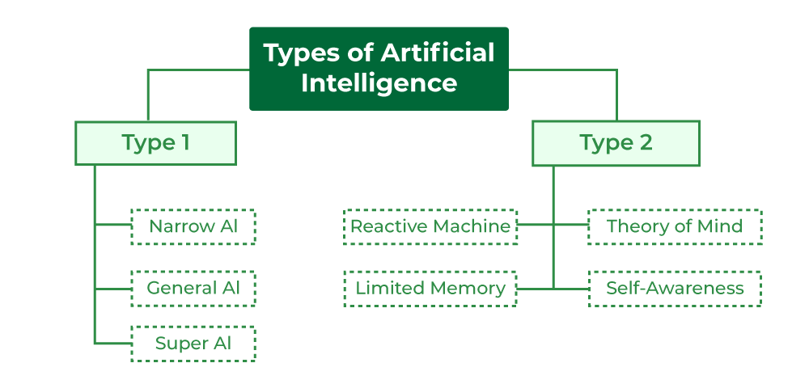

Based on Capabilities of AI -Type 1
  - Narrow AI
  - General AI
  - Super AI

Based on the Functionality of AI- Type 2
  - Reactive Machines
  - Limited Theory
  - Theory of Mind
  - Self-awareness

Based on Capabilities of AI -Type 1

1.NARROW AI:
Narrow AI, also known as artificial narrow intelligence (ANI) or weak AI, describes AI tools designed to carry out very specific actions or commands. ANI technologies are built to serve and excel in one cognitive capability, and cannot independently learn skills beyond its design. They often utilize machine learning and neural network algorithms to complete these specified tasks.
2.General AI:
It is known as Strong AI. It refers to AI systems that have human intelligence and abilities to perform various tasks. Systems have capability to understand, learn and apply across a wide range of tasks that are similar to how a human can adapt to various tasks. In general AI remains a theoretical concept, and now no AI can achieve this level of intelligence.
3.Super AI:
It is known as Superintelligent AI that surpasses intelligence of human in solving-problem, creativity, and overall abilities. Super AI develops emotions, desires, need and beliefs of their own. They are able to make decisions of their own and solve problem of its own.
Based on the Functionality of AI- Type 2
1.Reactive Machines:
Reactive machines are the foremost basic sort of AI system. this suggests that they can’t form memories or use past experiences to influence present -made a choice, they will only react to currently existing situations hence “Reactive”. These are the most basic type of AI and can only react to the environment, they cannot form memories or make decisions based on past experiences.
2.Limited Memory:
It is comprised of machine learning models that the device derives knowledge from previously-learned information, stored data, or events. Unlike Reactive machines, limited memory learns from the past by observing actions or data fed to them to create experiential knowledge.
3.Theory of Mind:
In this sort of AI decision-making ability is adequate to the extent of the human mind, but by machines. while some machines currently exhibit humanlike capabilities like voice assistants, for example, none are fully capable of holding conversations relative to human standards.
4.Self-Awareness:
AI involves machines that have human-level consciousness. this type of AI isn’t currently alive but would be considered the foremost advanced sort of AI known to man. These AI systems possess consciousness and self-awareness, but this is currently the stuff of science fiction, and not yet a reality.
FUTURE OF AI:
Artificial intelligence (AI) has a bright future, but it also faces several difficulties.
AI is predicted to grow increasingly pervasive as technology develops, revolutionising sectors including healthcare, banking, and transportation.
After all, many jobs formerly carried out by human hands have been mechanized as technology has improved.
It makes sense to worry that the development of clever computers may spell the beginning of the end for employment as we know it.
Explore our comprehensive comparison of our top AI programs to make an informed decision that propels your career forward in the exciting field of Artificial Intelligence.
Discover the details, features, and benefits of each program, and find the perfect fit that aligns with your goals and aspirations.
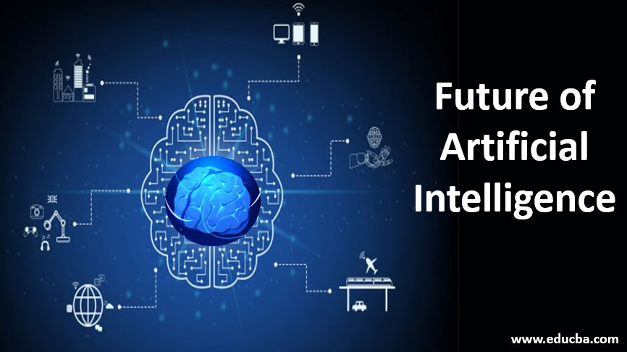

Applications of AI

we covered some fundamental AI techniques. In this article we take the next step and will discuss 5 applications of AI: Image recognition, Speech recognition, automatic translation, Q&A and Games.

For a lot of tasks, computers are becoming or are already better than humans. The calculator on your cell phone for example, can calculate the most difficult multiplications in an instance that would take people a few minutes and a piece of paper and pen. It has already been a long time since the world champion of chess was able to beat the strongest chess computers. In the past few years however, computers started doing typically human things such as seeing and hearing, which they do as good as, if not better than people. Google can recognize exactly which things are present on an image and Siri can understand what you are saying, to name a few examples. In the coming years the intelligence of these applications will increase in a rapid pace, due to developments in the field of neural networks and increased computational power. The increased accuracy, availability, and ease of implementation of artificial intelligence methods creates opportunities for companies to apply them in their business. As an example, insurance companies use AI to read claims from their clients, understand if the claim is difficult or easy, and it can give a recommendation on how to handle the claim. The insurance employee then only needs to do a quick check before approving the recommendation. This can save a lot of time and increase the quality of the work. This is just one example. In the remainder of this article, we will discuss 5 exciting applications in which we will see great development in the coming years:
• Image recognition
• Speech recognition
• Translation
• Q&A
• Games
These developments will make applications cheaper and more accurate, opening the door for business to use them.

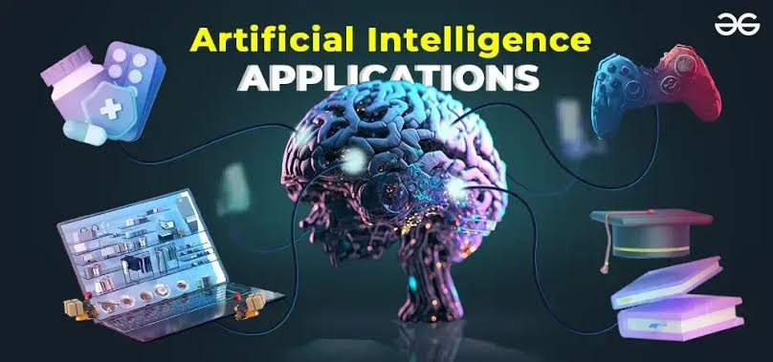

Automobiles

Artificial Intelligence is bringing revolutionary changes in the field of automobiles. From speedometers to self-driving cars, Artificial Intelligence is really doing a significant difference in these sectors. AI is sued to detect the traffic on the street and provide the best route out the present all routes to the driver. It uses sensors, GPS technology, and control signals to bring the vehicle the best path. Let’s take a closer look at AI applications in Automobiles.

ADAS: Advanced Driving Assistance System or ADAS is an AI algorithm that is known for processing some of major and sensitive data that includes driving assistance, crash detection, parking assistance, and so on. The algorithm has been designed in such a way that it automatically starts alarming to prevent any collisions.

Traffic Management: With the help of AI systems, now it has become easier to analyze traffic data from various sources, including vehicles, sensors, and cameras. This feature helps in boosting driving assistance by offering alternate routes. This AI algorithm has been designed in such a way that it is well capable of assisting users with real-time traffic insight and by offering the fastest route as an alternative to users to save time efficiently.

Emission Reduction: This feature detects and learns patterns from the given inputs i.e. from the driving pattern of the user and based on this it strategizes to perform efficient driving patterns by reducing emissions. This algorithm is well capable of analyzing routes, traffic, car performance patterns, and so on.

Autonomous Driving: This AI approach enables automatic driving and navigating vehicles without actual human intervention. Sensors like LIDAR, RADAR, and other sensors help in collecting additional data to analyze the surroundings for taking optimal decisions in the real world.

Agriculture

Artificial Intelligence is also becoming a part of agriculture and farmers’ life. It is used to detect various parameters such as the amount of water and moisture, amount of deficient nutrients, etc in the soil. There is also a machine that uses AI to detect where the weeds are growing, where the soil is infertile, etc. Let’s take a closer look at AI applications in Agriculture.

Stock Monitoring: To have rigorous monitoring, and ensure that crops that not being affected by any disease, AI uses CN to check crop feeds live and alarms when any abnormality arises.

Supply Chain: The AI algorithm helps in analyzing and preparing the inventory to maintain the supply chain stock. Although it’s not new, for the agriculture field, it does help farmers to ensure the demands are being met with minimal loss.

Pest Management: AI algorithms can analyze data from multiple sources to identify early warnings to their respective farmers. This technology also enables less usage of harmful pesticides by offering the best resources for pest management.
Forecasting: With the help of AI, analyzing the weather forecast and crop growth has become more convenient in the field of agriculture and the algorithms help farmers to grow crops with effective business decisions

Human Resource

As we know, much of the hiring processes are done online these days. The online selection processes are done using the voice and camera permission of the candidate’s device. Here Artificial Intelligence is sued to detect any kind of malpractice behavior and many other things. It is also used to detect any candidate’s personality in some cases. This reduces the effort of the hiring team and also enhances the efficiency of the selection process. Let’s take a closer look at AI applications in Human Resources.

Screening: With the help of AI, the screening process of candidates can be automated to reduce the timeframe and eliminate excess resources for this task. This helps shortlist potential candidates, and resumes and assess other insightful information in no time.

Onboarding: Offering a personalized onboarding kit has become famous in many tech companies and this enables HR professionals to complete the initial paperwork in a short time.

Performance: This feature enables HR professionals to perform an exercise to evaluate the employee’s performance based on the derived data and provide insights where the scope of improvement is required. This process generally takes time if attempted manually, with the help of AI algorithms, all the desired outputs can be derived in the shortest possible time.

Workforce Planning: To predict future work plans and align resources, AI can be helpful in the human resource sector. This requires a predictive analysis based on which workforce planning is being performed.

Finance

According to some recent surveys, 80% of banks accept that AI can provide them benefits according to their decisions in finance. From providing corporate finance advice to predicting the future outcome relate to finance, AI is capable of them Also it is used to send automated tests and mail, predict risk in loans, and detect any unwanted transactional activities, of the targeted customers. Spam and fraud filters, uncharacterized actions, responding to threats, etc are the tools that help in the field. Let’s take a closer look at AI applications in Finance.
Fraud Detection: AI algorithms can analyze large volumes of financial data to identify patterns and anomalies that can lead to any fraudulent activity. By continuously learning from historical data, AI is well capable of handling & working with such datasets & it enables the ability to prevent from any future threats.

Risk Assessment: AI algorithms help in enabling safeguard risk assessment models by analyzing large datasets and identifying potential risks in real-time.

Forecasting: AI-powered tools can assist in financial planning and forecasting that can create easy opportunities for businesses to make effective business decisions. This can be achieved by analyzing historical data, market trends, and economic indicators.

Image recognition

Recognizing images is an easy task for most of us. We don’t have any trouble differentiating a car from a tiger or recognizing that a car is still a car when you observe it from the front instead of from the side. This task has been proven considerably more difficult for computers, but recent progress in image recognition accuracy has resulted in interesting applications. Because different vendors like Google and IBM are offering their preprogrammed algorithms open source and software libraries like Tensorflow1 make it possible to construct your own algorithms, visual recognition is becoming more accessible for the public.

Well-known applications of image recognition are Google’s shopper app or facial recognition for security cams. Such applications are already using image recognition on a daily basis, however there has been a lot of development in other areas over the last few years. IBM Watson, which we know from playing Jeopardy, has developed its image recognition skills in the field of medicine.

IBM Research has been working on deep learning techniques for computer vision that could be used to recognize whether skin irregularities are melanoma. They created an ensemble of methods that can segment skin lesions and methods that can detect the area and surrounding tissue for melanoma and tested it on a large publicly available dataset, which they describe in a pre-print of the article. The vision of IBM is that at a certain point medical staff can send a picture of skin irregularities to Watson, the same way that they send blood sample to the lab.

Facial recognition, which we mainly know from security cameras, has also been developed in other areas. A survey of 150 retail executives by Computer Services Corporation, which was held in the UK in 2015, suggested that a quarter of all British shops use facial recognition software. The software is used for security, as one might expect, but also to track customers to observe their behavior as an effect of product displays, or the traffic flow in the store.

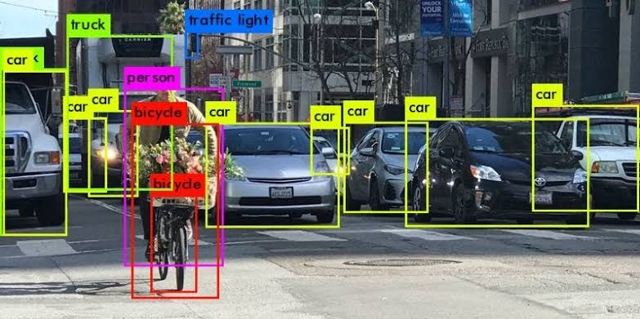

Speech recognition

Speech recognition is an AI application that recognizes speech and can turn spoken words into written words. It is hardly used on its own but it is largely used as an addition to Chatbots, virtual agents and mobile applications. Well known examples are Apple’s Siri, Google Home and Microsoft’s Alexa. Speech recognition started already in 1952 with ‘Audrey’. Audrey was able to recognize digits spoken in a single voice, which is quite impressive given the computers back then. Today we have applications on our phone and in our car that can respond to our voice.

Not only the number of applications with voice recognition capacity has increased, also the accuracy of voice to words has improved dramatically over the last few years according to KPCB.

One of the business applications that has gained quite a lot of ground is the use of speech recognition in health care. A lot of physicians are working with an electronic health record (EHR) to document patient information, however this has been said to delay the consults and to restrict the patient narrative. Using speech recognition, patient documentation can be recorded in a flexible and fast manner, which allows the physician to pay more attention to the patient. This solution is already offered by different vendors such as Nuance and M*Modal.

The rapid improvement of speech recognition accuracy offers a lot of opportunities in the near future. Having all our soft- and hardware voice controlled might not be as far away as many people think.



Translation

A different topic with large business implications is automatic translation. This topic can be defined as the process of translating text from one language to another by using software. Traditionally, translation was done by substituting each word by its closest counterpart in the other language.

While this works reasonably well for single words, a pair of words or sentences are generally harder to process correctly due to the fact that relations between words are important for the meaning of a sentence, but such nuances cannot be captured when each word is analysed separately.

The usage of deep learning has had a significant impact on the quality of machine translations by completely shifting the paradigm. Rather than working in a rulebased way, powered by human decision making, translation using a neural network is completely based on mathematics.

On relatively basic texts, the GNMT system translations approach the quality of human translators. An experiment even showed that when you translate English to Korean and subsequently translate English to Japanese, the model is able to translate Korean to Japanese reasonably well, without any prior training focused on the formal link between the two languages. One article even asked the question: “have computers invented their own internal language?”.

The impact of quality translations in a global economy are enormous. With business translations originally dominated by conversions between European languages, the need for translations to Chinese, Japanese, and Korean is increasing. A simple example is one that Uber was investigating, where automatic translation takes place between you and your local Uber driver, who can only communicate in Chinese

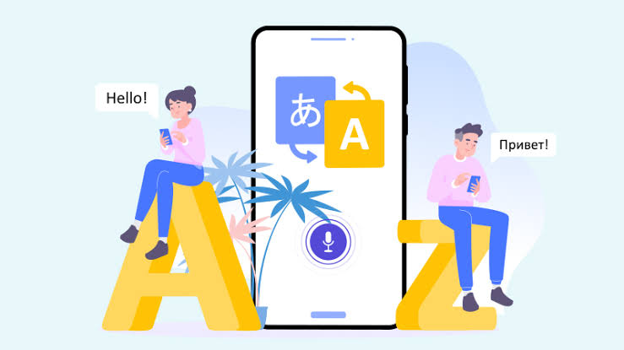

Question answering

Q&A agents or Chatbots are another example of applying AI to language. When talking about the ability of having conversations, distinctions are made in the domain and the way of generating an answer of the agent. A chatbot can be focused on answering questions in an open or closed domain.

When it operates in an open domain, it should be able to answer general questions that can concern any topic (see for example clever Bot). This is generally harder than a closed domain, which concerns only a limited number of topics.

Closed domains, however, have very good business application such as answering questions at helpdesks. A couple of years ago, there was a breakthrough in question answering interest, when IBM Watson beat humans in a game of Jeopardy, a well-known American quiz show10.

More recently another breakthrough was made by Google, who can now give chatbots the ability to have a short-term memory, which gives the chatbot the ability to mimic real-life conversations more realistically. The ability of machines to recognize intent (or the purpose) from a question and to answer it in a variety of ways, is again something that can be seen in many business applications.

After an intent is distilled from the command of a user, it can be linked to a specific follow up action. This action can range anywhere from asking a return question to the retrieval of information from the internet.

In the area of customer service, Chatbots are quickly becoming the norm, one example being IP soft’s Amelia.

Standard queries are already handled automatically, with only the difficult ones being forwarded to human decision makers.


Game/ Solver

One of the most exciting applications of AI lies in playing games. Playing a game well requires you to not only know the rules, but to calculate the next possible moves within these rules, and finally make a careful judgement on which move would give you to best chance to win. If computers can play games as well as human players, there are no reasons why they cannot learn any other difficult task that people do in their daily work (although human supervision probably remains needed).

Recently there was a big step forward in the field of games when the world Champion of Go was beaten by a computer for the first time. Go is a game that cannot be brute-force calculated, since the number of possible moves is higher than the number of stars in the universe.

The top Go players of the world rely for a large part on their intuition to come to the best moves. Google’s AlphaGo (a neural network-based go-engine), however, learned how to play like a top human player by studying millions of human games.

The AI controls over 120 variables in Google’s datacenters, such as the windows, fans and cooling systems, optimizing for energy usage while keeping computing performance up. The optimization potentially lowers Google’s energy bill for hundreds of millions over several years.

Another application lies in healthcare, where an app of DeepMind saves nurses over two hours of time per day by warning about upcoming acute kidney failure. These are two applications, but since this is a newly developed field there is a huge potential for more. Think about predicting stock prices, optimizing the layout of distribution centers. Imagination and available data are the limit.


The Need for AI
The need for AI is fueled by the fact that it is a technology that can enhance machines by equipping them with intelligence. The technology is used to have machines help humans by teaching themselves to adjust, adapt, refer to more data and process that quickly in order to provide a for a better or alternative answer where possible.
The introduction of AI is to create technology that allows machines to function in an intelligent manner with or without human supervision (Bermudez, 2017). The huge task of simulating or creating intelligence is broken down into sub-problems in order to:
• Create intelligent systems which can exhibit smart behaviour with an in-built ability to learn, validate, explain, and suggest a suitable course of action to its users.
• Help machines find solutions to complex problems in a similar way that humans do and apply similar logic in the form of heuristic (self-learning) algorithms to calculate and display the required output.
An AI system is composed of two main elements - an agent and its surrounding environment. An agent can be either a human or a machine. An agent can be anything that can perceive its environment through sensors and act upon that environment through effectors. The intelligence of agents is calculated by their ability to create goals and achieve them. Common applications of AI include - Natural Language Processing, Gaming, Speech Recognition, Vision Systems, and more, whose applications can be found across the Healthcare and Automotive sectors etc.

Cloud Computing Services
Cloud Computing is the system of using a robust network of remote servers to store, manage, and process data. It operates via a network of computers connected to each other and the user via the Internet rather than a local server or individual personal computer. A cloud computing system keeps its critical data on remote servers rather than distributing copies of the same data files to individual client devices. Video-steaming cloud services stream data across the Internet to a player application on the viewing device rather than using the local storage such as Digital Versatile Discs (DVD’s) or Compact Discs (CD’s).

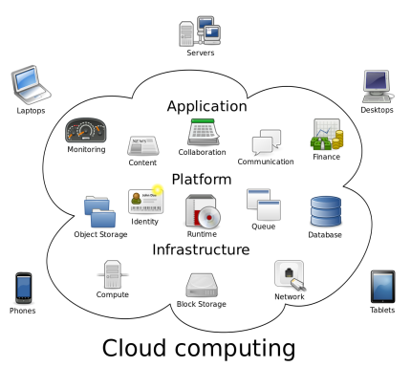

Fig 1.4: The working of cloud computing (Wikipedia)

Challenges of AI
Artificial intelligence (AI) is driving great advancements in technology, from self-driving cars to personalized virtual assistants. But its rapid expansion is not without hurdles.
In this article, we’ll tackle the different challenges that AI faces today. More importantly, we’ll also explore innovative solutions and strategies for overcoming these obstacles.
All of these advantages show the practical use of AI in many industries. Still, it's always important to consider the challenges of AI such as its ethical and societal implications as it continues to be integrated into these different fields.
So let’s unravel the challenges of AI and find the answers to the pressing questions that’ll shape its future.

- Data Quality and Availability.
- Bias and Fairness.
- Transparency and Explainability.
- Ethical Concerns.
- Regulation and Governance.
- Security and Robustness.
- International Cooperation.
- Job Displacement.

Data Quality and Availability

There’s a need for extensive, unbiased, and high-quality datasets for effective AI model training. Making sure that AI models are built upon datasets that are both representative and free from bias is a top priority for responsible and effective AI development.

To guarantee the relevance and reliability of data, organizations that use AI should have a robust data collection process that accommodates most, if not all of the following: Diverse data sources

- Data augmentation techniques
- Rigorous labelling and annotation
- Bias detection and mitigation
- Transparency and continuous monitoring
- Open data initiatives
- Partnerships with external organizations
- Active collaboration between experts

Bias and Fairness
AI systems have the potential to perpetuate or exacerbate biases present in their training data. This results in unfair or discriminatory outcomes, particularly in domains like hiring, criminal justice, and lending.

In general, addressing the challenges of AI needs an approach that combines technical, ethical, and regulatory measures to build more unbiased and fair AI systems. Here are some suggestions:


- Technical measure: Implement strong bias detection techniques during both the data collection and model training stages.
- Ethical measure: Employ diversity and inclusivity in development teams to reduce bias and promote fairness in AI system design.
- Regulatory measure: Develop ethical guidelines and regulatory standards for AI applications.


Transparency and Explainability

Many AI models, especially deep learning models, are often considered "black boxes". This means that it’s difficult to understand their decision-making processes. Still, this understanding is essential for trust and accountability.

So, a way to solve this problem of AI is to invest in research and the development of explainable AI (XAI) techniques that offer insights into model predictions. This’ll let users understand the factors influencing AI decisions.

We could also encourage AI models that prioritize transparency and accountability by design, alongside regulatory standards that require explainability in critical applications.

If we can promote the use of simpler, interpretable models and clear documentation of model architectures and training data, we can further enhance transparency and foster ethical AI.

Ethical Concerns
The use of AI raises ethical dilemmas such as privacy, surveillance, and the potential for misuse. This means that there’s a need to establish comprehensive guidelines and frameworks to guarantee the ethical use of AI.


One solution for this AI issue is to prioritize ethical considerations in AI development. Transparency, fairness, and accountability should be emphasized throughout the entire AI lifecycle, from data collection to delivery.

Interdisciplinary collaboration between technology experts, ethicists, policymakers, and stakeholders should also facilitate the creation of regulatory standards that govern AI usage.

Continuous public engagement and awareness campaigns also underscore the importance of ethical AI practices and the consequences of misuse. With collective efforts, we can successfully deal with all of these artificial intelligence problems and solutions.

Regulation and Governance
Determining responsibility for AI system decisions and actions is complex, especially in cases of system errors or misuse. To address this, establishing a clear legal and regulatory framework for AI applications is vital.

The roles and responsibilities of developers, operators, and users must all be defined.

This includes implementing transparency requirements, setting up regulatory bodies, and setting up industry standards for ethical and safe AI use.

Plus, continuous monitoring, compliance audits, and reporting mechanisms can make sure that people are following AI governance guidelines.

Also, integrating accountability and liability considerations into AI development processes can promote responsible AI innovation while addressing concerns related to regulatory enforcement.

Security and Robustness

AI systems can be vulnerable to malicious attacks, where slight modifications to input data can lead to incorrect results. This is why the security and robustness of AI models is a critical concern.


To mitigate this challenge, a multi-faceted approach is needed. Possible solutions to fortify the security and robustness of AI models against adversarial threats include the following:
- Developing intrusion detection systems specifically designed to identify malicious activities targeting AI
- Employing encryption methods to protect sensitive AI models and data
- Continuous monitoring for anomalies
- Collaborating with cybersecurity experts
- Adopting best practices for secure AI development

International Cooperation
As previously mentioned, AI development is a global endeavor, and international collaboration is necessary to address ethical, regulatory, and security challenges effectively.


International agreements and alliances must be established to facilitate knowledge-sharing, standardization, and harmonization of AI principles and policies.

Cross-border research collaborations, data exchange, and coordinated efforts in setting ethical standards and regulatory guidelines should be encouraged.

These can foster a more unified approach to AI development and governance.

International organizations or forums dedicated to AI discussions can collectively address global challenges, guaranteeing responsible and beneficial AI worldwide.

Job Displacement
Automation and AI technologies have the potential to replace certain jobs, which can lead to workforce disruptions. Potential solutions include investing in robust training programs that focus on reskilling and upskilling workers to adapt to changing job requirements.


Governments, businesses, and educational institutions can collaborate to identify emerging job sectors and promote lifelong learning. They can also support affected workers through financial assistance and career transition programs.

AI development efforts should also shift toward creating technologies that augment human capabilities rather than replace them. In turn, this promotes the development of new roles and opportunities.

Conclusion

We have discussed some of the applications of AI and can conclude that that there is a major opportunity for the business to improve, gain efficiency and define new business models by utilizing the power of AI. This was the 5th and last edition of our series on AI.

We started the series on AI by providing an overview of terms and definitions of AI9. In the 2nd blog we have discussed some of the fundamental techniques which are at the heart of AI.

In the 3rd article we went on and gave five applications of AI: Image recognition, Speech recognition, automatic translation, Q&A and Games. Then we continued and analyzed five technology trends that leapfrog AI. This was published in our 4th blog.
And then finally, in this 5th release we have provided some practical applications of AI in day-to-day life.

AI is and will remain a dynamic and broad filed encompassing several areas of expertise, ranging from computer science to mathematics, neuroscience all the way up to philosophy and even biology.

We hope that the topics discussed in our 5x5 on AI edition will help the reader to get an end-to-end overview of AI in a more practical sense rather than a bullet proof complete scientific exercise.





